Name of Student: Husam Ali Abdlla Nour | PRN:25070122086
Semester: III | Year : AY 2026-27
Subject: Programming with Java
ASSIGNMENT No : 13
TITLE : File Handling in Java
Problem Statement
Write a Java program to perform reading from and writing to a file using file handling operations.
Learning Objectives
To perform file reading and writing operations using Java file handling classes.

Programme
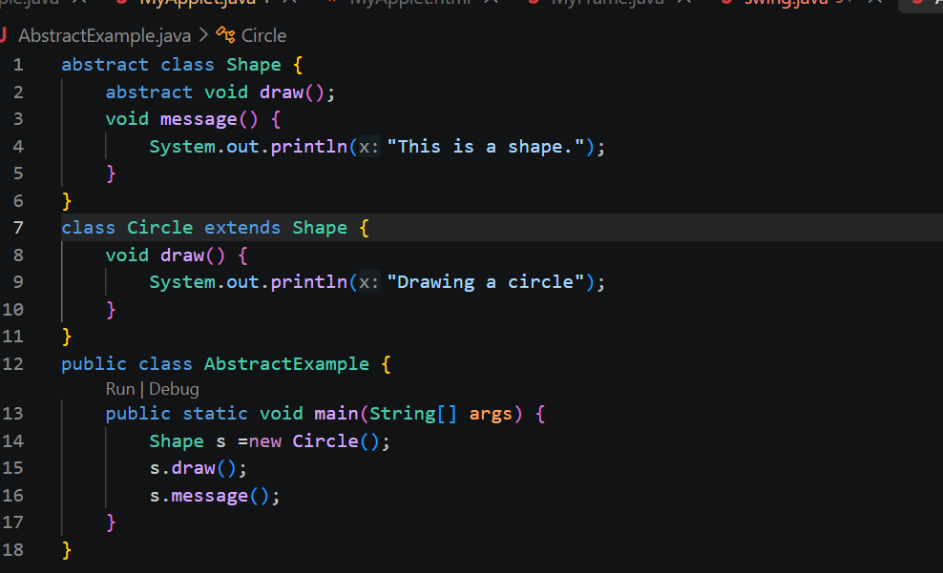

Practice questions
- Create an ATM program handling invalid withdrawal amount using try-catch.
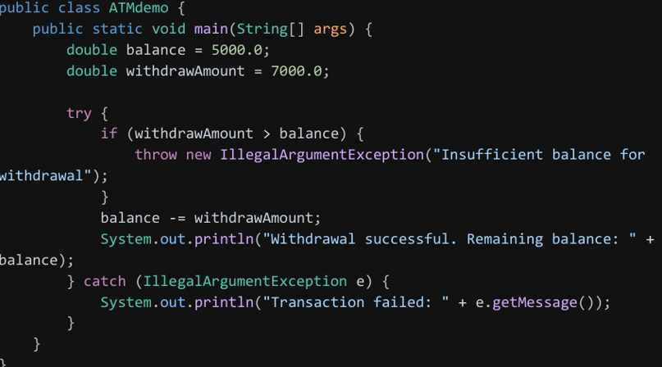
Output
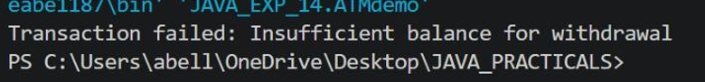
2. Create an Online Shopping program that handles an invalid product quantity entered by the user using a try-catch block. Display an appropriate error message if the quantity is less than or equal to zero.
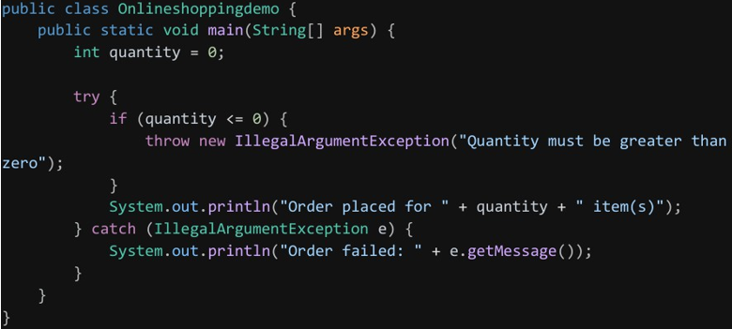
Output
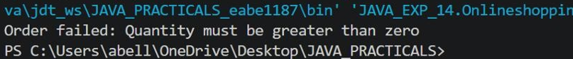

Conclusion
Exception handling allows a Java program to detect and respond to runtime errors gracefully instead of crashing. Multiple catch blocks let a single try block respond differently depending on the exception type, while nested try-catch supports handling errors at different levels of a program's logic — together making applications more robust and user-friendly.

